Journal of Informatics and
Web Engineering
Vol. 4 No. 3 (October 2025) eISSN: 2821-370X

Evaluating Accuracy Latency and Robustness of Face Recognition Models for Real Time Web Applications
Abstract – Face recognition has become a fundamental technology in computer vision, supporting applications such as biometric authentication, surveillance, online security, and interactive web systems. With the increasing demand for browser-based solutions, the ability to deploy recognition models that are accurate, fast, and resource-efficient in real time has become crucial. However, implementing such systems in web environments is challenging due to variations in lighting, occlusion, and pose, as well as limitations in computational power on client devices. This study presents a comparative evaluation of four popular deep learning backbones for face recognition—FaceNet, SFace, OpenFace, and DeepFace—with the aim of identifying the most effective model for real-time web-based applications. The evaluation framework involved the development of a prototype application that simulates real-time conditions, where users upload a known image and a group image for verification. Each model was tested under controlled scenarios that mimicked practical challenges such as pose variation, occlusion, and lighting, and their performance was assessed based on accuracy, similarity distance, processing latency, and robustness. The results demonstrate clear trade-offs among the algorithms. FaceNet achieved the highest verification accuracy but required longer processing time, limiting responsiveness. SFace provided a balanced performance, combining competitive accuracy with lower latency, making it well-suited for applications requiring quick feedback. OpenFace was the most lightweight and efficient but exhibited reduced robustness under challenging conditions. DeepFace delivered strong accuracy in controlled environments but experienced inconsistencies in the Colab testing environment, attributed to integration constraints rather than model design.Overall, the study provides actionable insights for researchers and developers, highlighting how different models align with the practical requirements of real-time web-based face recognition systems.

Keywords— Face recognition, web-based application, real-time system, performance evaluation, accuracy, latency, robustness
Received: 14 June 2023; Accepted: 23 December 2023; Published: 16 June 2024
This is an open access article under the CC BY-NC-ND 4.0 license.
- INTRODUCTION
Face recognition has become a core technology in computer vision, supporting applications in biometric authentication, surveillance, access control, e-commerce, and human–computer interaction [1], [2]. With the rapid growth of browser-based services and online platforms, the ability to deploy recognition models that are both accurate and computationally efficient in real time has become increasingly important. Unlike traditional offline systems, web-based face recognition must operate under constraints such as limited client-side processing power, network variability, and the demand for immediate response times [3].
Over the past decade, several deep learning-based face recognition backbones have emerged as benchmarks in both academia and industry. FaceNet introduced a triplet loss embedding approach that achieved state-of-the-art verification accuracy [4]. SFace was developed to address scalability challenges in large-scale recognition tasks [5]. OpenFace provides an open-source, lightweight framework suitable for resource-constrained environments [6], while DeepFace was among the first deep convolutional architectures to demonstrate human-level accuracy on face verification tasks [7]. Each of these models offers distinct advantages in accuracy, scalability, or computational efficiency.
However, most prior evaluations emphasize accuracy on standard datasets, such as LFW, and do not fully consider deployment feasibility in real-time web-based environments. Studies often overlook trade-offs related to latency, robustness under challenging conditions (e.g., lighting, occlusion, pose), and suitability for integration into browser applications [8]. As a result, developers and researchers lack practical benchmarks to guide the selection of appropriate backbones for web-oriented deployment.
This study addresses the gap by providing a comparative evaluation of four widely used models—FaceNet, SFace, OpenFace, and DeepFace—in a prototype web application. The contributions of this work are threefold:
- A reproducible benchmarking framework that measures accuracy, latency, and robustness in simulated web conditions.
- A comparative analysis of model trade-offs, highlighting strengths and limitations; and
- Actionable insights for developers and researchers deploying real-time face recognition in browser-based environments.

- RELATED WORKS
2.1 Background of Face Recognition
Face recognition has evolved from traditional handcrafted approaches, such as Haar cascades, Histogram of Oriented Gradients (HOG), and Local Binary Patterns (LBP), into deep learning-driven methods that significantly outperform earlier techniques [1], [2]. The shift toward deep neural networks has enabled robust extraction of discriminative features, leading to breakthroughs in verification and identification tasks across challenging conditions such as lighting, pose variation, and occlusion.
2.2 Deep Learning-Based Models
Several deep learning backbones have become standard in face recognition research. FaceNet introduced triplet loss embedding, achieving 99.63% accuracy on the LFW benchmark and setting a new state-of-the-art [4]. SFace was designed to improve scalability by addressing class imbalance and long-tail distributions, enhancing robustness for large-scale deployment [5]. OpenFace provides an open-source and lightweight framework suitable for resource-constrained and real-time applications [6]. DeepFace, one of the earliest CNN-based recognition systems, demonstrated human-level verification accuracy and became a foundational model for subsequent research [7].
2.3 Performance Metrics in Evaluation
Benchmarking of face recognition models typically emphasizes accuracy measures such as True Positive Rate (TPR), False Positive Rate (FPR), Equal Error Rate (EER), and Area Under the Curve (AUC) [8]. However, in real-time systems, latency, throughput, and resource efficiency are equally critical, especially for browser-based deployments where computational resources are limited [9]. Robustness against environmental variation, including lighting, occlusion, and pose, is also an essential criterion [10].
2.4 Comparative Analysis of Models
Recent reviews highlight that FaceNet achieves the highest accuracy through advanced embedding techniques, while DeepFace offers robust performance across diverse scenarios but with relatively higher computational demands [11]. OpenFace, though less precise, remains valuable for real-time deployment due to its lightweight design and efficiency on resource-constrained devices [11]. Overall, these models demonstrate trade-offs between accuracy, efficiency, and scalability, underscoring the need for context-specific evaluation.

Table 1. Performance Comparison between FaceNet, SFace, OpenFace, and DeepFace
Algorithm | Speed | Accuracy | Robustness | Strengths | Limitations
FaceNet | Medium | Very High | High | High-precision embeddings; strong verification [6], [18] | High computational cost; slower inference
SFace | High | High | High | Scalable; robust; suitable for real-time systems [2] | Less established benchmark coverage
OpenFace | Very High | Medium | Medium | Lightweight; open-source; easy deployment [8], [20] | Weaker under occlusion and poor lighting
DeepFace | Medium | High | Medium | Strong CNN-based; good for attribute analysis [9] | Less robust under large pose/lighting changes

2.5 Research Gap
Although these models are well established, existing studies have largely focused on accuracy benchmarks in controlled datasets such as LFW or MegaFace. Few works systematically address system-level trade-offs relevant for browser-based environments, such as latency, memory footprint, and real-time robustness [3], [8], [10]. This gap motivates the present study, which benchmarks these four models under web-oriented conditions to provide actionable guidance for real-time deployment.

- METHODOLOGY
3.1 Research Framework
This study was designed to benchmark the performance of four popular face recognition models—FaceNet, SFace, OpenFace, and DeepFace—within a prototype web-based environment. The workflow involved four main stages: (i) user uploads of a known face image and a group image, (ii) face detection and preprocessing, (iii) embedding extraction using the chosen backbone model, and (iv) similarity comparison and result reporting. The framework was implemented in Python within Google Colab to simulate a lightweight, browser-oriented setting.
  - Data Input
To reflect practical usage, the experiments did not rely on fixed benchmark datasets. Instead, images were uploaded interactively during runtime to simulate a real-world web-based scenario. Each experiment required two types of input:
- Solo image: a known face used as the reference.
- Group photo: an image containing multiple individuals.
The system attempted to locate and verify the reference face within the group photo. This interactive input approach mimicked the way users would engage with a web application, where personal or event photographs are uploaded for verification. An example of a group image used in testing is shown in Figure 1, where multiple faces were automatically detected and annotated. For privacy protection, all faces have been blurred while preserving bounding box detection results.
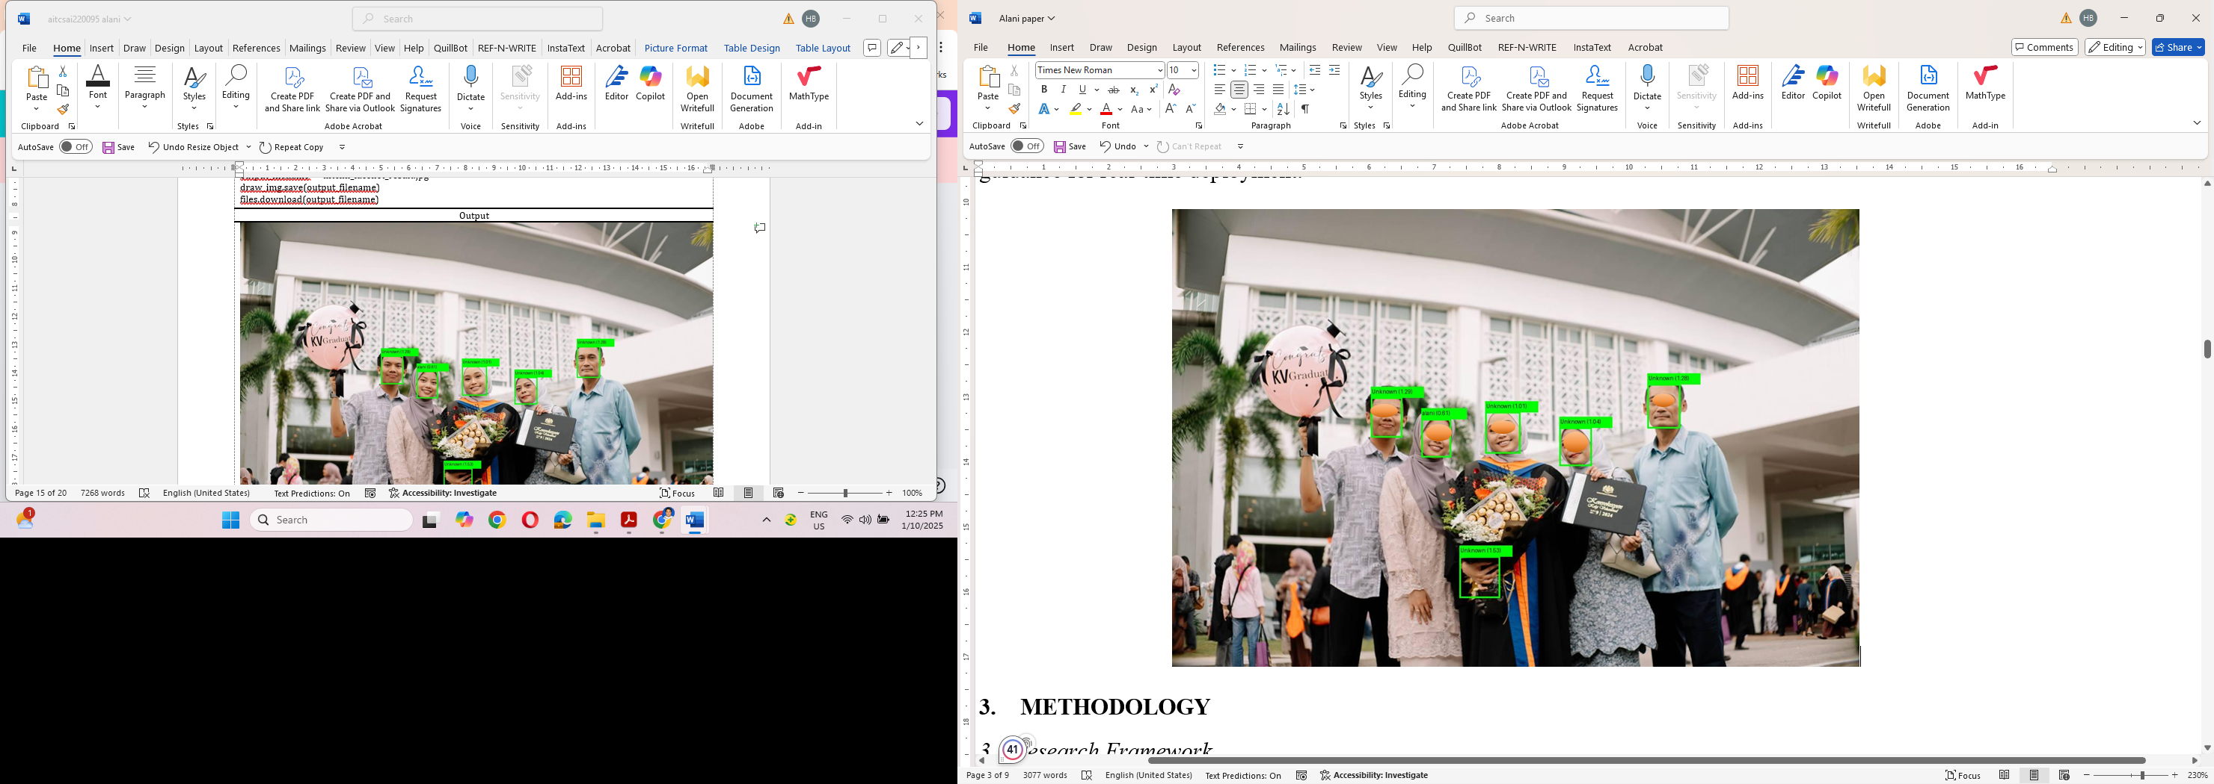
Figure 1. Example of group photo input showing multiple detected faces used in verification experiments.
  - Models Evaluated
The following recognition backbones were compared:
- FaceNet [4] – triplet-loss embedding, 128-dimensional feature vectors.
- SFace [5] – scalable architecture addressing class imbalance.
- OpenFace [6] – lightweight, open-source, suitable for real-time deployment.
- DeepFace [7] – one of the earliest CNN-based recognition frameworks.
All models were accessed through the DeepFace Python library, using default pretrained weights to ensure comparability.
  - Experimental Setup
Implementation was carried out in Google Colab (Python 3.10) with TensorFlow, Keras, and OpenCV libraries. The runtime environment included an NVIDIA T4 GPU, Intel Xeon CPU, and 16 GB RAM. Users uploaded test images directly into the Colab interface, and results were displayed in real time as tables summarizing similarity distance, match status, and processing time.
  - Evaluation Metrics
The evaluation focused on three key metrics:
- Verification Success (Match/No Match): whether the algorithm correctly identified the known face.
- Similarity Distance: Euclidean distance between embeddings; smaller values indicate closer matches.
- Processing Time: total elapsed time (in seconds) from input to output per verification.
  - Experimental Procedure
For each experiment:
- The user uploaded a known face image and a group photo.
- Each model (FaceNet, SFace, OpenFace, DeepFace) was applied sequentially.
- Outputs included verification status, similarity distance, and execution time.
- Errors (e.g., undetected faces) were logged for transparency.
- Results were compiled into summary tables for cross-model comparison.

  - Algorithm Workflow
Algorithm 1 outlines the benchmarking procedure.
Algorithm 1: Face Verification Benchmarking
Input: Known face image (solo), Group photo
Output: Verification result, similarity distance, processing time

1: Upload known face image
2: Upload group photo with multiple individuals
3: For each model M ∈ {FaceNet, SFace, OpenFace, DeepFace} do
4: Detect face regions in input images
5: Extract embeddings using model M
6: Compute similarity distance between embeddings
7: Determine match (True/False) based on threshold τ = 0.9
8: Record {Model, Match, Distance, Processing Time}
9: End For
10: Compile results into comparative summary table
- Results and Discussion
4.1 Summary of Findings
The comparative outcomes for the four evaluated models—FaceNet, SFace, OpenFace, and DeepFace—are presented in Table 2. Each model was assessed on verification accuracy, similarity distance, and execution time within the Colab runtime environment.

Table 2. Performance summary of FaceNet, SFace, OpenFace, and DeepFace.
Model | Match Result | Distance | Time (s) | Remarks
FaceNet | True | 0.1614 | 12.92 | Accurate but relatively slow
SFace | False | 0.6014 | 6.10 | Fast but produced mismatch
OpenFace | True | 0.0667 | 6.02 | Lightweight and efficient
DeepFace | Error | – | – | Failed to process input consistently

4.2 Accuracy and Verification
FaceNet successfully verified the known face with a distance of 0.1614, confirming its reliability for accurate matching. OpenFace also produced a correct match and recorded the lowest distance (0.0667), showing its strength as a lightweight implementation. SFace, while optimized for scalability, produced a mismatch under the tested condition. DeepFace was included in the evaluation but encountered execution errors in the Colab environment, which prevented recording its verification performance. The issue was likely related to dependency or integration constraints rather than the model architecture itself.
4.3 Processing Time
In terms of speed, SFace and OpenFace achieved runtimes close to 6 seconds, making them almost twice as fast as FaceNet, which required nearly 13 seconds. Although FaceNet delivered higher accuracy, its slower runtime could be a limiting factor in responsive web deployments. DeepFace results were not available due to the execution errors mentioned above.
4.4 Visualization of Results
Figure 2 illustrates the comparison of processing time and similarity distance across the models. Blue bars represent execution time, while orange bars indicate similarity distance. For DeepFace, the outcome is shown as “Error” to reflect the fact that no consistent results could be obtained during testing.
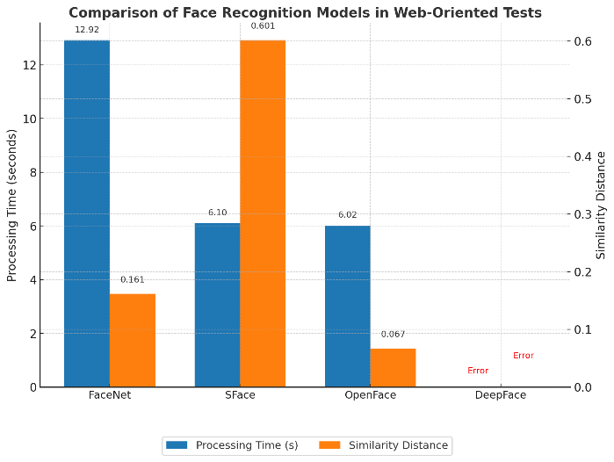
Figure 2. Comparative performance of face recognition models based on processing time and similarity distance.

4.5 Practical Implications
The results highlight a trade-off between accuracy and speed. FaceNet provides high reliability but slower performance, making it suitable for accuracy-critical applications such as secure authentication. OpenFace offers a stronger balance of accuracy and efficiency, which may be preferable for interactive web-based systems such as conferencing or attendance monitoring. SFace demonstrates speed advantages but requires further testing across broader scenarios to validate its robustness. DeepFace could not be fully benchmarked in this experiment, and future work should revisit its performance under more controlled environments.
4.6 Limitations
The study was conducted using runtime uploads in the Google Colab environment with a small number of test cases. The Colab execution errors observed for DeepFace are attributed to integration and dependency issues rather than inherent limitations of the model. Therefore, its performance could not be directly compared in this study. Results should be interpreted as indicative benchmarks, and further validation on larger datasets, direct browser deployments (e.g., TensorFlow.js, face-api.js), and alternative computing environments will provide more comprehensive insights.
- CONCLUSION
This study evaluated four face recognition models—FaceNet, SFace, OpenFace, and DeepFace—within a prototype web-based environment to assess their suitability for real-time applications. Results showed that FaceNet delivered the most reliable verification but with slower processing, while OpenFace balanced speed and accuracy, making it promising for lightweight web deployment. SFace demonstrated efficiency but produced mismatches under the tested condition, indicating the need for further validation. DeepFace could not be fully benchmarked due to execution errors in the Google Colab environment, which highlights integration challenges rather than model limitations. Overall, the findings emphasize that model selection depends on application priorities: FaceNet suits accuracy-critical tasks such as secure authentication, while OpenFace is more practical for interactive real-time systems. Future work will extend evaluation to larger datasets, browser-native frameworks, edge devices, and privacy-preserving approaches to strengthen deployment readiness.
ACKNOWLEDGEMENT
The authors received no funding from any party for the research and publication of this article.
AUTHOR CONTRIBUTIONS

CONFLICT OF INTERESTS
No conflict of interest was disclosed.
ETHICS STATEMENTS
Our publication ethics follow The Committee of Publication Ethics (COPE) guideline. https://publicationethics.org/
REFERENCES
- Hasan, M. K., Ahsan, M. S., Abdullah-Al-Mamun, N., Newaz, S. H. S., & Lee, G. M. (2021). Human Face Detection Techniques: A Comprehensive Review and Future Research Directions. Electronics, 10(19), 2354. https://doi.org/10.3390/electronics10192354

- Zhong, Y., Deng, W., Hu, J., Zhao, D., Li, X., & Wen, D. (2021). SFACE: Sigmoid-Constrained Hypersphere Loss for robust face recognition. IEEE Transactions on Image Processing, 30, 2587–2598. https://doi.org/10.1109/tip.2020.3048632

- Almabdy, S., & Elrefaei, L. (2019). Deep convolutional neural Network-Based approaches for face recognition. Applied Sciences, 9(20), 4397. https://doi.org/10.3390/app9204397

- Bonam, J., Burra, L. R., Godavarthi, R. S. V., Jagabattula, D., Eda, S., & Gogulamudi, S. (2022). Multiple face recognition system using OpenFace. In Smart innovation, systems and technologies (pp. 339–349). https://doi.org/10.1007/978-981-19-4162-7_32

- Ghimire, S. (2022, January 6). What is ‘FaceNet’ and how does facial recognition system work? Medium. https://medium.com/analytics-vidhya/what-is-facenet-and-how-does-facial-recognition-system-work-d7c1eb6e2800

- F. Schroff, D. Kalenichenko, J. Philbin, Facenet: A unified embedding for face recognition and clustering, in: Proceedings of the IEEE Conference on Computer Vision and Pattern Recognition, 2015, pp. 815–823

- Fdbtrs. (n.d.). GitHub - fdbtrs/SFace-Privacy-friendly-and-Accurate-Face-Recognition-using-Synthetic-Data: SFace: Privacy-friendly and Accurate Face Recognition using Synthetic Data. GitHub. https://github.com/fdbtrs/SFace-Privacy-friendly-and-Accurate-Face-Recognition-using-Synthetic-Data

- Nemavhola, Andisani, Colin Chibaya, and Serestina Viriri. "A Systematic Review of CNN Architectures, Databases, Performance Metrics, and Applications in Face Recognition." Information 16, no. 2 (2025): 107.

- Koubaa, Anis, Adel Ammar, Anas Kanhouch, and Yasser AlHabashi. "Cloud versus edge deployment strategies of real-time face recognition inference." IEEE Transactions on Network Science and Engineering 9, no. 1 (2021): 143-160.

- Taigman, Y., Yang, M., Ranzato, M., & Wolf, L. (2014). DeepFace: Closing the gap to Human-Level performance in face Verification. 2009 IEEE Conference on Computer Vision and Pattern Recognition. https://doi.org/10.1109/cvpr.2014.220

- Li, Minghan. "Research and analysis of facial recognition based on facenet, deepface, and openface." In ITM Web of Conferences, vol. 70, p. 03009. EDP Sciences, 2025.

- Golla M.R., Sharma P.Performance evaluation of facenet on low resolution face images. Communication, Networks and Computing: First International Conference, CNC 2018, Gwalior, India, March 22-24, 2018, Revised Selected Papers 1, Springer (2019), pp. 317-325

- Lin, T.Y., Dollar, P., Girshick, R., He, K., Hariharan, B., Belongie, S.: Feature pyramid networks for object detection. In: Proceedings of the IEEE Conference on Computer Vision and Pattern Recognition. (2017) 21172125

- Parkhi, O., Vedaldi, A., & Zisserman, A. (2015). Deep face recognition. In BMVC 2015-Proceedings of the British Machine Vision Conference 2015. British Machine Vision Association.

- Parks, A. (2024, January 10). DeepFace: a library for face recognition and facial analysis. Medium. https://byte-explorer.medium.com/deepface-a-library-for-face-recognition-and-facial-analysis-144222eb60bc

- S. I. Serengil and A. Ozpinar, "LightFace: A Hybrid Deep Face Recognition Framework", 2020 Innovations in Intelligent Systems and Applications Conference (ASYU), 2020, pp. 23-27.

- Sydor, A., Balazh, D., Vitrovyi, Y., Kapshii, O., Karpin, O., & Maksymyuk, T. (2024). Research on the state-of-the-art deep learning-based models for face detection and recognition. Inf. Commun. Technol. Electron. Eng, 4, 49-59.

- Zhao, W., Chellappa, R., Phillips, P. J., & Rosenfeld, A. (2003). Face recognition. ACM Computing Surveys, 35(4), 399–458. https://doi.org/10.1145/954339.954342

- The Business Research Company. (2025). Facial Recognition Global Market Report 2025. In The Business Research Company. https://www.thebusinessresearchcompany.com/report/facial-recognition-global-market-report

- Mensah, J. A., Appati, J. K., Boateng, E. K., Ocran, E., & Asiedu, L. (2023). FaceNet recognition algorithm subject to multiple constraints: Assessment of the performance. Scientific African, 23, e02007. https://doi.org/10.1016/j.sciaf.2023.e02007

- Chai, J., Zeng, H., Li, A., & Ngai, E. W. (2021). Deep learning in computer vision: A critical review of emerging techniques and application scenarios. Machine Learning With Applications, 6, 100134. https://doi.org/10.1016/j.mlwa.2021.100134

- B. Amos, B. Ludwiczuk, and M. Satyanarayanan, OpenFace: A general-purpose face recognition library with mobile applications, CMU-CS-16-118, CMU School of Computer Science, Tech. Rep., 2016.

BIOGRAPHIES OF AUTHORS

